## Yellow Pine (YPN)

**General Information**

**Cover Type Overview**

**Yellow Pine (YPN)**

* 26,229 acres / 10,615 hectares
* Only occurs on the east side of the Sierra crest.
* Crosswalk to EVeg: Regional Dominance Type 1
  + Eastside Pine
  + Jeffrey Pine
  + Ponderosa Pine
* Crosswalk to EVeg: Regional Dominance Type 2
  + any
* Crosswalk to Presettlement Fire Regime Type
  + Yellow Pine
* Crosswalk to LandFire Biophysical Settings
  + 0610310 California Montane Jeffrey Pine (–Ponderosa Pine) Woodland

**Yellow Pine with Aspen (YPN-ASP)**

* 8 acres / 3 hectares
* This type is created by overlaying the NRIS TERRA Inventory of Aspen on top of the EVeg layer. Where it intersects with YPN it is assigned to YPN-ASP.

**Vegetation Description**

**Yellow Pine** The YPN landcover type is characterized by yellow pine species such as *Pinus ponderosa* or *Pinus jeffreyi* that occur on the east side of the Sierra crest (LandFire 2007a). Relatively pure stands of *P. jeffreyi* may occur, or they may mix with other tree species including *Abies concolor,* *Juniperus occidentalis, Pinus contorta* ssp. *murrayana,* and *Quercus kelloggi* (Fites-Kaufman et al. 2007, Fitzhugh 1988). Their understory may include both montane forest and Great Basin shrubs, including but not limited to *Ceanothus, Arctostaphylos, Symphoricarpos*, *Artemisia tridentata*, *Purshia tridentata, Ericameria nauseosa*, *Cercocarpus,* and *Holodiscus*. Herbaceous plants may include *Wyethia, Balsamorhiza sagittata, Festuca, Calamagrostis,* and *Elymus* (LandFire 2007a, Fitzhugh 1988).

Without disturbance, except for naturally occuring fire, a mosaic of even-aged patches develops, with open spaces and dense sapling stands. *Q. kelloggi* or *Juniperus occidentalis* may form an understory, but pure stands of pine also are found. An open stand of low shrubs, and a grassy herb layer are typical. Crowns of pines are open, allowing light, wind and rain to penetrate, whereas other associated trees provide more dense foliage.

**Yellow Pine with Aspen (YPN-ASP)** Because this type occurs only in the buffer, not in the actual project area, we are using the west side Aspen type. For projects focused on areas east of the Sierra crest, a separate model for this type of Aspen should be used.

When *Populus tremuloides* co-occurs with conifers on the west side of the Sierran crest, it is typically found in smaller patches, often less than 2 ha (5 acres) in size. Mature stands in which *P. tremuloides* are still dominant are usually relatively open. Average canopy closures range from 60 to 100 percent in young and intermediate-aged stands and from 25 to 60 percent in mature stands. The open nature of the stands results in substantial light penetration to the ground (Verner 1988).

**Distribution**

**Yellow Pine** This landcover type occurs on all aspects from about 1200 m to 1980 m (4000-6500 ft) in elevation, east of the Sierra Nevada crest (Fitzhugh 1988). It is usually found on volcanic and granitic substrates, and are shallow with a frigid soil temperature regime (LandFire 2007a).

**Yellow Pine with Aspen** Again, we are utilizing an aspen model developed for the west side.

Sites supporting *P. tremuloides* are associated with added soil moisture, i.e., azonal wet sites. These sites are often close to streams, lakes, and meadows. Other sites include rock reservoirs, springs and seeps. Terrain can be simple to complex. At lower elevations, topographic conditions for this type tends toward positions resulting in relatively colder, wetter conditions within the prevailing climate, e.g., ravines, north slopes, wet depressions, etc. (LandFire 2007b).

**Disturbances**

**Wildfire**

**Yellow Pine** Wildfires are common and frequent; mortality depends on vegetation vulnerability and wildfire intensity. Low mortality fires kill small trees and consume above-ground portions of shrubs and herbs, but do not kill large trees or below-ground organs of most shrubs and herbs which promptly re-sprout. High mortality fires kill large as well as small trees, and may kill many of the shrubs and herbs as well. Fire kills the above-ground portions of the shrubs and herbs, but most shrubs and herbs promptly resprout from surviving below-ground organs. Wildfires may trigger transitions between developmental condition classes.

The relatively long needles of yellow pines and relatively open structure of theses stands make for dry surface and ground fuels that burn readily. Thus, fires in these stands burn more frequently than those in adjacent forests (Fites-Kaufman et al. 2007). In fact, fire is an integral part of the ecology of yellow pines. Fire has allowed yellow pines to dominate sites where it is the potential climax as well as sites where it would otherwise be seral to more shade-tolerant tree species. *P. ponderosa* and *P. jeffreyi* have evolved with a thick bark and open crown structure that allows them to survive most fires. Mature trees will self-prune, leaving a smooth bole which reduces aerial fire spread. Also, fire creates favorable seedbeds for seedling establishment (Habeck 1992).

Data on fire return intervals (FRIs) are available from a few review papers. Skinner and Chang (1996) aggregated FRIs from the Sierra Nevada. Van de Water and Safford’s 2011 review paper aggregates hundreds of articles, conference proceedings, and LandFire data on fire return intervals, with an emphasis on Californian sources. We also include here data from the pertinent individual LandFire BpS model (2007a).

For yellow pine forests (not restricted to east side types), Van de Water and Safford (2011) found a mean FRI of 11 years, median of 7 years, mean min of 5 years and mean max of 40 years. Skinner and Chang (1996) examined studies of east side *P. ponderosa* forests in the southern Cascades and found median FRIs of 8-16 years, minimums of 6-8 years, and maximums of 15-32 years. For east side *P. ponderosa-A. concolor* forests in the southern Cascades, they separated pre-1850 values from the entire period of record. In that study, the median FRI was 10 years, with a minimum of 3 years and a maximum of 71 years. LandFire’s California Montane Jeffrey Pine (–Ponderosa Pine) Woodland for the northern Sierra estimated FRIs of 165 years for replacement fire, 80 years for mixed fire, 11 years for surface fire, and 9 years overall (2007a). We recalculated these numbers using condition-specific information and using only high and low mortality fire categories, which resulted in a mean FRI of 121 years for high mortality fire, 10 years for low mortality fire, and 9 years for any fire.

**Yellow Pine with Aspen** Sites supporting *P. tremuloides* are maintained by stand-replacing disturbances that allow regeneration from below-ground suckers. Upland clones are impaired or suppressed by conifer ingrowth and overtopping and intensive grazing that inhibits growth. In a reference condition scenario, a few stands will advance toward conifer dominance, but in the current landscape scenario where fire has been reduced from reference conditions there are many more conifer-dominated mixed aspen stands (LandFire 2007b, Verner 1988).

Van de Water and Safford (2011) found a mean fire return interval of 19 years, median of 20 years, mean min interval of 10 years and mean max of 90 years for Aspen. The LandFire model for northern Sierra Nevada aspen that is seral to conifers predicts a mean FRI of 37 years. Replacement FRI has a mean of 150 years with a range of 50-300 years, while mixed severity FRI is 250 years, and low severity fire FRI is 60 years (2007b). We recalculated these numbers using condition-specific information and using only high and low mortality fire categories, which resulted in an interval of 92 years for high mortality fire, 91 years for low mortality fire, and 46 years for any fire.

Table 1. Fire return intervals (years) and percentage of high versus low mortality fires. Numbers for YPN were derived from BpS model 0610581 (LandFire 2007a) and Skinner and Chang (1996). Numbers for YPN-ASP were derived from BpS model 0610610 (LandFire 2007c) and Safford (pers. comm. 2013).

|  |  |  |  |  |  |
| --- | --- | --- | --- | --- | --- |
| **Variant** | **Fire Mortality** | **Mean** | **Min** | **Max** | **% of Fires** |
| YPN | High | 121 | – | – | 29 |
| Low | 10 | – | – | 71 |
| All Fires | 9 | 3 | 71 | 100 |
| YPN–ASP | High | 92 | – | – | 50 |
| Low | 91 | – | – | 50 |
| All Fires | 46 | 20 | 200 | 100 |

**Other Disturbance**

Other disturbances are not currently modeled, but may, depending on the condition affected and mortality levels, reset patches to early development, maintain existing condition classes, or shift/accelerate succession to a more open condition.

**Vegetation Condition Classes**

We recognize five separate condition classes for YPN and YPN -ASP. The condition classes described below are based on the classes described in the pertinent LandFire Biophysical Setting model descriptions, which in turn were based on a “5-box” state and transition models describing major successional stages related to fire regime condition classification. According to the Fire Regime Condition Class guidebook, up to five successional classes may be utilized to describe age, size, canopy cover, and vegetation composition, ranging from early seral (post-disturbance) to late seral (such as old growth) (Barrett et al. 2010).

The YPN variant is assigned to five separate condition classes: Early Development (ED), Mid Development Open (MDO), Mid Development Closed (MDC), Late Development Open (LDO, and Late Development Closed (LDC). The YPN -ASP variant is also assigned to five condition classes: Early Development – Aspen (ED-A), Mid Development – Aspen (MD-A), Mid Development – Aspen with Conifer (MD-AC), Late Development Closed (LDC), and Late Development – Conifer with Aspen (LD-CA).

**Yellow Pine Variant**

**Early Development (ED)**

**Description** Grasses, forbs, low shrubs, and sparse to moderate cover of trees (primarily *P. ponderosa* or *P. jeffreyi*) seedlings/saplings with an open canopy. This condition is characterized by the recruitment of a new cohort of early successional, shade-intolerant tree species into an open area created by a stand-replacing disturbance. Following stand-replacing disturbance, some sites are dominated by dense shrub stands composed of *P. tridentata, Arctostaphylos,* and/or *Ceanothus*, depending on location. Other postfire sites are more open and dominated by dense pine seedlings, bunchgrasses and forbs.

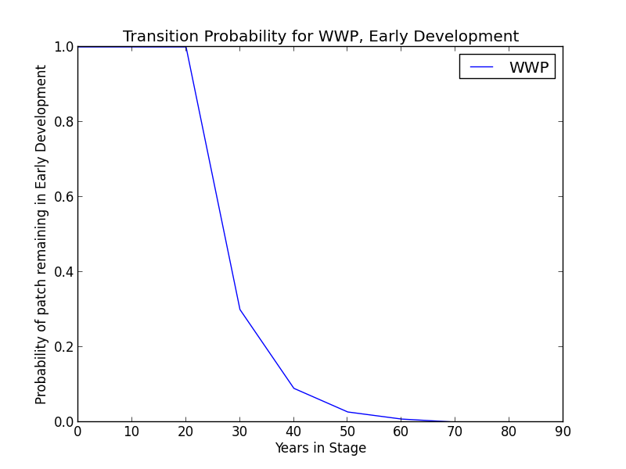

**Succession Transition** In the absence of disturbance, this condition will begin transitioning to MDC or MDO after 40 years at a rate of 0.7 per timestep. The transition to MDO is twice as likely as transition to MDC. At 80 years, all stands will have succeeded to either MDC or MDO.

**Wildfire Transition** High mortality wildfire (100% of fires in this condition) recycles the patch through the ED condition, regardless of soil type. Low mortality wildfire is not modeled for this condition.

**Mid Development - Open (MDO)**

**Description** Open mid-development forest with diverse herbaceous understory and scattered woody shrubs. Conifers, primarily *P. ponderosa* or *P. jeffreyi*, are medium sized. Herbs and other species gradually decline as growing trees begin to shade understory. Maintained by frequent burning. Canopy cover is less than 40% (LandFire 2007a).

**Succession Transition** This class will maintain under low mortality disturbance, but after 40 years without fire it begins transitioning to MDC at a rate of 0.8 per time step. Succession to LDO occurs once the patch has been in mid development for 170 years. The rate of succession per time step is 0.6. After 230 years, all stands will have succeeded.

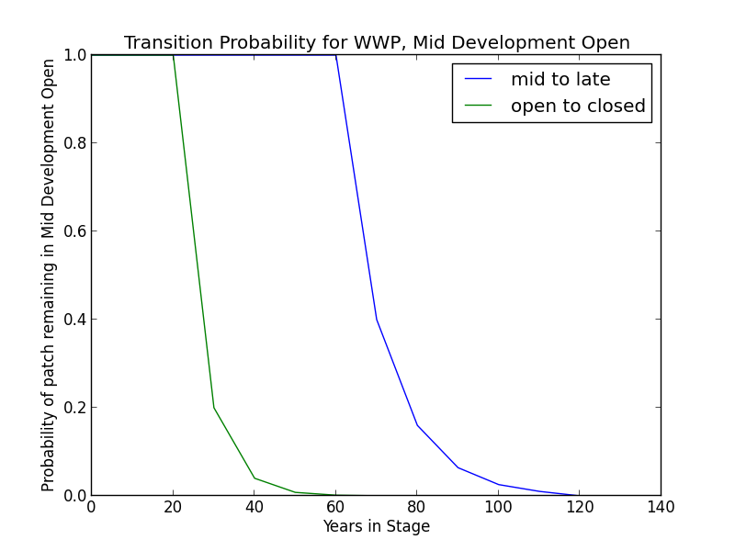

**Wildfire Transition** High mortality wildfire (5.8% of fires in this condition) recycles the patch through the Early Development condition. Low mortality wildfire (94.2%) maintains the patch in MDO.

**Mid Development - Closed (MDC)**

**Description** Dense mid-development forest. “Overstocked” pole to large pole size trees, primarily *P. ponderosa* or *P. jeffreyi,* susceptible to stagnation. Marginal understory associated with limited site resources. Developes where fire frequency is too low to thin small trees. Canopy cover is over 40% (LandFire 2007a).

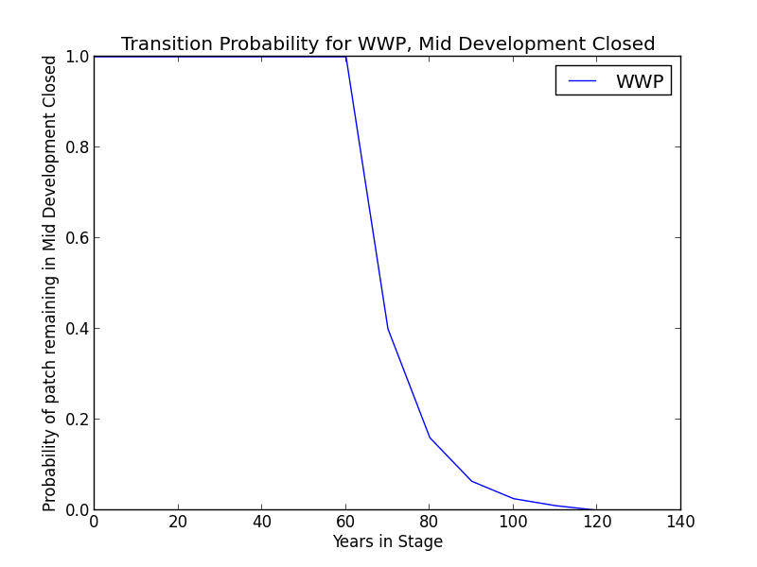**Succession Transition** After 100 years without a wildfire-triggered transition, this class will begin transitioning to LDC. Patches moving between MDC and MDO begin transitioning after 100 years since transition to mid development. The rate of succession per time step is 0.4. After 200 years, all stands will have succeeded.

**Wildfire Transition** High mortality wildfire (14.8% of fires in this condition) recycles the patch through the Early Development condition. Low mortality wildfire (85.2%) opens the stand up to MDO about half of the time; otherwise, the patch remains in MDC.

**Late Development - Open (LDO)**

**Description** Open late-development forest with large and very large trees, primarily *P. ponderosa* or *P. jeffreyi*. Trees are widely spaced and the understory is open and often diverse. Surface fuels are limited due to frequent burning. Canopy cover is less than 40% (LandFire 2007a).

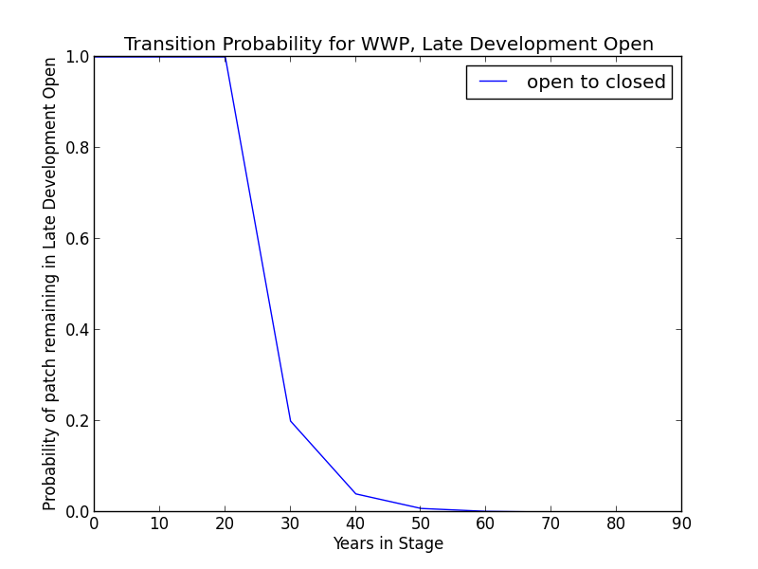**Succession Transition** This class will maintain under low mortality disturbance, but after 50 years without fire, this class succeeds to LDC at a rate of 0.7 per timestep.

**Wildfire Transition** High mortality wildfire (1.1% of fires in this condition) recycles the patch through the Early Development condition. Low mortality wildfire (98.9%) maintains the patch in LDO.

**Late Development - Closed (LDC)**

**Description** Dense late-development forest, primarily *P. ponderosa* or *P. jeffreyi* with large and very large trees, often with significant within-stand mortality. Substantial surface fuel accumulation and ladder fuels. Canopy cover exceeds 40% (LandFire 2007a).

**Succession Transition** This class will maintain in the absence of disturbance.

**Wildfire Transition** High mortality wildfire (26.9% of fires in this condition) recycles the patch through the Early Development condition. Low mortality wildfire (73.1%) maintains the patch in LDC.

**Aspen Variant**

**Early Development – Aspen (ED–A)**

**Description** Grasses, forbs, low shrubs, and sparse to moderate cover of tree seedlings/saplings (primarily *P. tremuloides*) with an open canopy. This condition is characterized by the recruitment of a new cohort of early successional, shade-intolerant tree species into an open area created by a stand-replacing disturbance.

Following disturbance, succession proceeds rapidly from an herbaceous layer to shrubs and trees, which invade together (Verner 1988). *P. tremuloides* suckers over 6ft tall develop within about 10 years (LandFire 2007c).

**Succession Transition** Unless it burns, a patch in the early condition persists for 10 years, at which point it transitions to MD-A.

**Wildfire Transition** High mortality wildfire (100% of fires in this condition) recycles the patch through the ED–A condition. Low mortality wildfire is not modeled for this condition.

**Mid Development – Aspen (MD–A)**

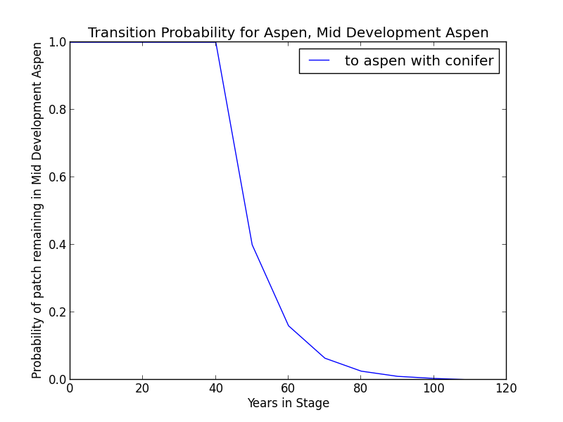**Description** *P. tremuloides* trees 5-16” DBH. Canopy cover is highly variable, and can range from 40-100%. These patches range in age from 10 to 110 years. Some understory conifers, predominantly *P. ponderosa* or *P. jeffreyi,* are encroaching, but *P. tremuloides* is still the dominant component of the stand (LandFire 2007c).

**Succession Transition** MD-A persists for at least 50 years in the absence of fire, after which stands begin transitioning to MD-AC at a rate of 0.6 per timestep. After 100 years all remaining MD-A patches transition to MD-AC.

**Wildfire** **Transition** High mortality wildfire (100% of fires in this condition) recycles the patch through the ED–A condition. Low mortality wildfire is not modeled for this condition.

**Mid Development – Aspen with Conifer (MD–AC)**

**Description** These stands have been protected from fire since the last stand-replacing disturbance. *P. tremuloides* trees are predominantly 16” DBH and greater. Conifers (predominantly *P. P. ponderosa* or *P. jeffreyi*) are present and overtopping the aspen. Conifers are pole to medium-sized, and conifer cover is at least 40% (LandFire 2007c).

**Succession Transition** MD-AC persists for 100 years in the absence of fire, after which stands transition to LDC.

**Wildfire Transition** High mortality wildfire (55.6% of fires in this condition) returns the patch to ED-A. Low mortality wildfire (44.4%) maintains the patch in MD–AC.

**Late Development – Closed (LDC)**

**Description** Some *P. tremuloides* continue to be present in the understory, but large *P. ponderosa* or *P. jeffreyi* are now the dominant tree species, having overtopped the *P. tremuloides.* Smaller conifers are present in the midstory as well (LandFire 2007a). This condition class is analogous to the LDC condition for the YPN variant.

**Succession Transition** This class will maintain in the absence of disturbance.

**Wildfire Transition** High mortality wildfire (9% of fires in this condition) will return the patch to ED–A. Low mortality wildfire (91%) usually has little effect, although 15% of the time it opens the stand up to LD-CA.

**Late Development – Conifer with Aspen (LD–CA)**

**Description** If stands are sufficiently protected from fire such that conifer species overtop *P. tremuloides* and become large, they may be able to withstand some fire that more sensitive *P. tremuloides* cannot. When this occurs, it creates a patch characterized by late development conifers, such as *P. ponderosa* or *P. jeffreyi*, and early seral *P. tremuloides*.

**Succession Transition** LD-CA persists for 70 years in the absence of fire, after which stands transition to LDC.

**Wildfire Transition** High mortality wildfire (20% of fires in this condition) returns the patch to ED-A. Low mortality wildfire (80%) maintains the stand in LD-CA.

**Condition Classification**

Table 2. Classification of cover condition for YPN. Diameter at Breast Height (DBH) and Cover From Above (CFA) values taken from EVeg polygons. DBH categories are: null, 0-0.9”, 1-4.9”, 5-9.9”, 10-19.9”, 20-29.9”, 30”+. CFA categories are null, 0-10%, 10-20%, … , 90-100%. Each row in the table below should be read with a boolean AND across each column of a row.

|  |  |  |  |  |  |
| --- | --- | --- | --- | --- | --- |
| Cover Condition | Overstory Tree  Diameter 1 (DBH) | Overstory Tree  Diameter 2 (DBH) | Total Tree  CFA (%) | Conifer  CFA (%) | Hardwood  CFA (%) |
| Early All | 0-4.9” | any | any | any | any |
| Mid Open | 5-19.9” | any | <40 | any | any |
| Mid Closed | 5-19.9” | any | >40 | any | any |
| Late Open | 20”+ | any | <40 | any | any |
| Late Closed | 20”+ | any | >40 | any | any |

Methodology for assigning condition classes to YPN–ASP is still under development.

**Draft Model**

(See PDF) Disturbance-Succession model for YPN and YPN–ASP.

**References**

Barrett, S., D. Havlina, J. Jones, W. Hann, C. Frame, D. Hamilton, K. Schon, T. Demeo, L. Hutter, and J. Menakis. *Interagency Fire Regime Condition Class Guidebook*. Version 3.0. USDA Forest Service, US Department of the Interior, and The Nature Conservancy, 2010. <http://www.frcc.gov>. Accessed 5 June 2013.

Fitzhugh, E. Lee. “Eastside Pine (EPN).” *A Guide to Wildlife Habitats of California*, edited by Kenneth E. Mayer and William F. Laudenslayer. California Deparment of Fish and Game, 1988. <http://www.dfg.ca.gov/biogeodata/cwhr/pdfs/EPN.pdf>. Accessed 4 December 2012.

Habeck, R. J. “Pinus ponderosa var. ponderosa.” *Fire Effects Information System*, U.S. Department of Agriculture, Forest Service, Rocky Mountain Research Station, Fire Sciences Laboratory, 1992. <http://www.fs.fed.us/database/feis/plants/tree/quekel/all.html>. Accessed 21 December 2012.

LandFire. “Biophysical Setting Models.” Biophysical Setting 0610310: California Montane Jeffrey Pine (–Ponderosa Pine) Woodland. 2007a. LANDFIRE Project, U.S. Department of Agriculture, Forest Service; U.S. Department of the Interior. <http://www.landfire.gov/national_veg_models_op2.php>. Accessed 9 November 2012.

LandFire. “Biophysical Setting Models.” Biophysical Setting 0610610: Inter-Mountain Basins Aspen-Mixed Conifer Forest and Woodland. 2007b. LANDFIRE Project, U.S. Department of Agriculture, Forest Service; U.S. Department of the Interior. <http://www.landfire.gov/national_veg_models_op2.php>. Accessed 7 January 2013.

Safford, Hugh S. Personal communication, 5 May 2013.

Skinner, Carl N. and Chi-Ru Chang. “Fire Regimes, Past and Present.” *Sierra Nevada Ecosystem Project: Final report to Congress, vol. II, Assessments and scientific basis for management options*. Davis: University of California, Centers for Water and Wildland Resources, 1996.

Van de Water, Kip M. and Hugh D. Safford. “A Summary of Fire Frequency Estimates for California Vegetation Before Euro-American Settlement.” *Fire Ecology* 7.3 (2011): 26-57. doi: 10.4996/fireecology.0703026.

Verner, Jared. “Aspen (ASP).” *A Guide to Wildlife Habitats of California*, edited by Kenneth E. Mayer and William F. Laudenslayer. California Deparment of Fish and Game, 1988. <http://www.dfg.ca.gov/biogeodata/cwhr/pdfs/ASP.pdf>. Accessed 4 December 2012.